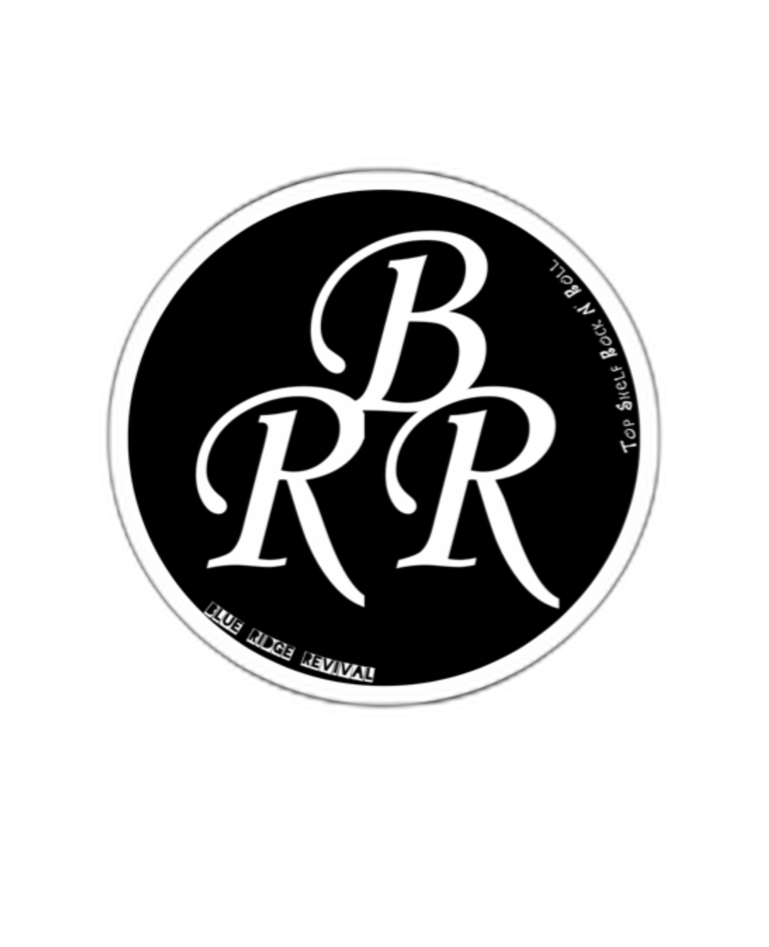

| **Contact Information:  Jaden Uniek:**  (276) 252-5088  jadenuniekmusic@gmail.com  **Nick Mosko**  (304) 887-8157  nickmosko@hotmail.com | **Bio:**  **Label:** Independent  **Location:** Wytheville, Virginia  **Genres:** Rock n' Roll  **Years Active:** 2023-Present |
| --- | --- |
| **BRR Team:  Band Members:**  Jaden Uniek – Lead Vocals, Guitar  Nick Mosko – Drums, Vocals  Corey Pless – Bass, Vocals  Connor Henderson – Lead Guitar  **Auxiliary Band Members:**  Joe Mosko – Lead Guitar  **Stage Crew:**  Matthew Cantrell - Crew/Instrument Tech  **Creative:**  Trey Tate - Digital Media Manager | **Gear:  BRR proudly uses the following brands:**  **Microphones:**  Shure  **Guitars and Basses:**  Gibson, Fender, Music Man  **Strings:**  Daddario, Rotosound  **Amps:**  Marshall, Orange, Ampeg  **Drums:**  Gretsch Drums, Meinl, Pro-Mark, DW Hardware |

**About the Band:**  
  
**Blue Ridge Revival is a rock n’ roll band based in Wytheville, VA. Formed in 2023, they have drawn sonic comparisons to Led Zeppelin, Bad Company, Tom Petty and Greta Van Fleet, they bring a sound to the stage full of pure energy and excitement. The musicians create an entertaining and exhilarating atmosphere in any venue. The songs they write are full of life’s lessons; they brim with passion and a yearning to present a worldview that includes the ups and down of love, life, and the journey in which we are all a part.**

**Since 2023, they have built a steady following across the Southwest Virginia region through hard work and building a connection with the music lovers of the world. They have opened for nationally touring artists such as Eva Under Fire and Slippery When Wet (A Bon Jovi Tribute Experience). Currently, the band is finishing their first full-length album which will be released in the Summer of 2025. Right now you can hear their singles “NoseDive” and “Heaven And Hell” on Spotify, Apple Music, Amazon Music, Tidal and all other streaming platforms.**

**At any BRR show, you can expect to hear popular songs from a who’s who of timeless artists such as AC/DC, Black Sabbath, Free, Ted Nugent, Tyler Childers, Sturgill Simpson, Led Zeppelin, Lynyrd Skynyrd along with plenty of other influential and iconic artists. Getting down to the bottom line, the mission of Blue Ridge Revival is to give the world honest and exciting music.**